Personal Assistants required in Sudbury
9 hrs a week Ref: 4523
£9.15 per hour pro rata
Closing Date: 27 August 2021
About Me

I am a 7 year old boy with Autism, I live with my family and have both a pet cat and a dog.

We have a very happy and bubbly family dynamic, which is always busy with activities and having fun. I get to spend a lot of time with both my parents and grandparents.

I need someone to help me 9 hours a week for 2-2-1 care to allow my parents some respite and time to work. I already have this in place during the school holidays, but have now had increased funding to make this all year round. This job will range from personal care, play and stimulation at home, support at family events, local activities, meal times and bedtime routines, though not all at once!

Someone with knowledge of Makaton or PECS would be brilliant as this is great for me to communicate with.

Person Specification
Essential | Desirable
- To be able to work flexible hours during term time only. | - Local to Sudbury area.
- Able to manage time well and be prompt and punctual when working. | - Someone that has caring experience  with children.
- Someone who is a Chatty, friendly, and proactive with children | - Confident and able to self-direct their  Own tasks without prompting.
- Someone who is trustworthy and respects confidentiality. | - Good attitude towards family pets (cat  and dog)
- Someone who is reliable, caring and has common sense. | - Knowledge of Makaton or PECS
- Someone who good communication skills. | - Experience of Autism
- Use of a car and willing to use it to go out on activities in the local community | - Someone who is understanding of a  smoking household

Shifts and Main Responsibilities

Although this job description is correct at present, it may change from time to time after negotiation with the post holder.

As this job is only for the term time the shifts are going to be 3 nights a week after school. These will be Monday, Wednesday, and Friday 3.15pm – 6.15pm. This is a flexible arrangement to be discussed at interview, but please note your expected availability on the application form. We have people that already cover the holiday periods, but it’s possible that in the school holidays extra hours might become available for holiday and sickness cover.
Tasks that may be included within the working hours are as follows:
- Assist with meal times
- Bedtime routine
- Personal care when required (nappy changes)
- Support during family events
- Attend local community activities
- Promote fun, games and playtime

When time allows my parents or grandparents may ask for additional tasks, or expect you to use your initiative to support me in anything you deem to help me.

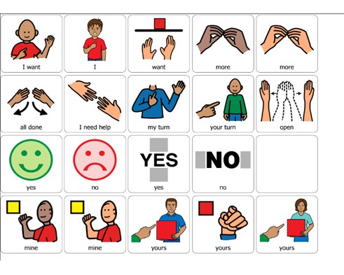

Terms and Conditions
Pay Rate: | £9.15 per hour pro rata (please note, that if the shift is under an hour, the pay will be adjusted).
Annual Leave | The annual holiday entitlement for this position will be equivalent to the work which would normally be done during 5.6 consecutive weeks.
Background Checks | A satisfactory Enhanced Disclosure and Barring Service check is required for this position.  If your application is successful, you will be required to provide details of two referees, one of which must be your current or most recent employer, or character references if you have not been employed.
Expenses | You will be reimbursed for any expenses incurred during the role.
Trial Period | This post is subject to a probationary period of 6 months.

How to apply:

If you wish to apply for this position, please complete the enclosed application form (quoting the reference number SIL4523) and return to the address below.

SIL4523 - Suffolk Independent Living
IP City Centre
1 Bath Street
Ipswich
IP2 8SD

Or email suffolk@silmail.org

